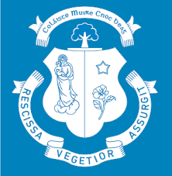
AGREED REPORT
20/5/25
- Congratulations to Colin Maxwell and the editorial team of this year’s Knockbeg College Annual. This year’s publication is of a particularly notable standard.
- Congratulations to our Senior Prefect team who impressively mc’d the Parent’s Day award ceremony.
- The Board thanks all those involved in organising the recent Darkness into Light event here in Knockbeg.
- The Board wishes all our Leaving Certificate and Junior Certificate students the best of luck with their upcoming state examinations.
- The Board ratified a number of key initiatives at this meeting including
- Proposal to explore the possibility of a Leaving Certificate Applied Class in Knockbeg for 2026/27.
- Admissions Policy 2026/27
- Annual Report to Kildare and Leighlin diocese
- Early Friday finish on timetable for last 7 weeks of 2025/26.

